**Aleks Itskovich**

Write a function that takes two lists of integers and returns a list containing tuples with corresponding elements from both the lists. For example - f ([1, 2, 3], [4, 5, 6]) -> [(1, 4), (1,5), (1,6), (2, 4), (2, 5), (2, 6), (3, 4), (3 ,5), (3, 6)]. If either list is null, the result is null. The lists do not have to be the same length. Solve this using recursion. You may **NOT** use the length() function or lambda() function or comprehension lists to do your solution.

***Haskell***

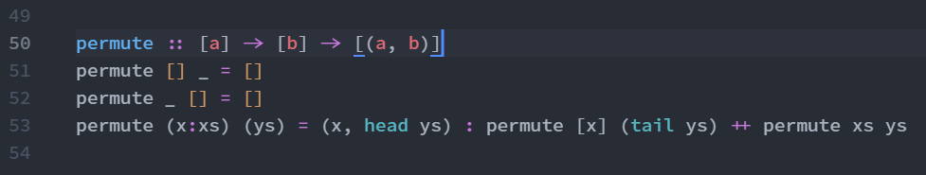

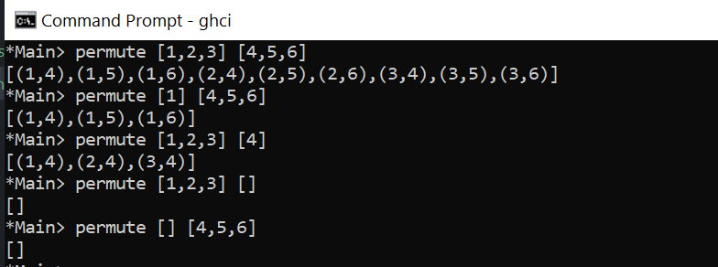

***Scheme***

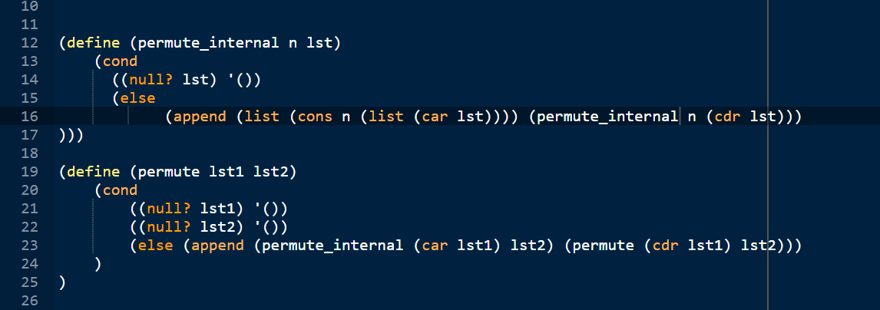

Or as a single function (if helpers are not allowed):

